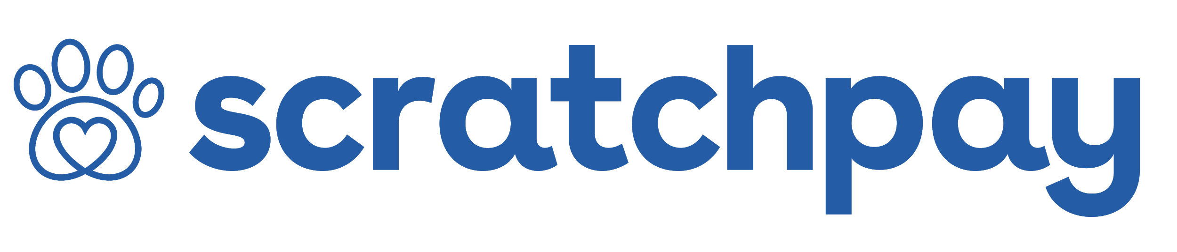
New Client Paperwork Massaging

Simply copy and paste the below message of your choice on your new client form/ paperwork. Or, feel free to mix and match! These are only suggestions.

When your pet needs you most, our Scratchpay payment plans can help make difficult financial decisions simple - 3 plan types & no hard credit check to see the plans you qualify for! Apply at Scratchpay.com.

Our Scratchpay payment plans can help you finance your pet’s care if unforeseen costs happen. There is no hard credit check to see which plans you qualify for. Apply at Scratchpay.com.

To learn more about the payment plans available to our clients, please visit Scratchpay.com.

